Chapter Two
Introduction to html/ XHTM
  - HyperText Mark-up Language ( HTML )
Internet programming includes broad variety of technologies spanning such diverse areas such as protocols for communication.
The word HTML, stands for Hypertext Markup Language, is the predominant markup language for web pages. A markup language is a set of markup tags, and HTML uses markup tags to describe web pages.
Mark-up means anything that is added to a document to add special meaning or provide extra information about it.
HTML is written in the form of HTML elements consisting of HTML tags surrounded by angle brackets (e.g. <html>) within the web page content.
HTML was invented in 1990 by a scientist called Tim Berners-Lee. An HTML file is a text file containing small markup tags. The markup tags tell the Web browser how to display the page.
Mark-up languages can be classified as one of these four types:
- Stylistic – indicating how the document should be presented e.g. adding bold or italics. HTML has tags e.g.<font>, <b> and <i> for stylistic mark-up - we'll see more of these when we start working with HTML.
- Structural – indicating how the document should be structured. In HTML, examples are <h1>, <h2> etc, <p> and <div>.
- Semantic – informing about the content of the data. In HTML, <title> is an example of this.
- Functional – adds functionality to the marked-up data, e.g. hyperlinks in HTML, embedded sound files etc.
The main language used for writing web pages is HTML.
- HTML tells a browser what text and images to display and how to format the text e.g. show it in bold or italics or to show it in a particular colour.
- A HTML file is just a text file – so you can start writing HTML in a simple editor like Windows Notepad.
- The HTML language is defined as a set of tags that are used to surround the text that will appear on the web page or to precede a piece of text. For example, the tag that denotes the start of a web page is <html>.
- Most tags in HTML have a start tag and an end tag. The start tag looks like <html> and the end tag looks like </html>.
You can easily edit HTML files using a WYSIWYG (what you see is what you get) editor like FrontPage, Dreamweaver, Claris Home Page, or Adobe PageMill instead of writing your markup tags in a plain text file. But
- If you want to design professional web pages using these tools will not be enough. You must be familiar with html codes.
- Results of these editors are big and sometimes chaotic code. Maintaining this code is very difficult.
- If you want to design dynamic web pages in future you will need to know html codes.
- If you need forms in your pages to send information to server and return result pages back to browser you will need to know html codes.

HTML tags usually come in pairs like <b> and </b>, but not always. The first tag in a pair is the start tag, the second tag is the end tag; which are refer for opening tags and closing tags. But, it doesn’t mean all tags has both open and close tags because there are empty tags (self close tag) which has only open tag like <br> and <img> tags.
HTML elements form the building blocks of all websites, it allows images and objects to be embedded and can be used to create interactive forms. It provides a means to create structured documents by denoting structural semantics for text such as headings, paragraphs, lists, links, quotes and other items. It can also embed scripts in languages such as JavaScript which affect the behavior of HTML webpage. HTML can also be used to include Cascading Style Sheets (CSS) to define the appearance and layout of text.
HTML tags are used to create the web page, and interpreted by any browser types such as internet explorer, nets cap, Mozilla, safari, etc. The purposes of these web browser types are to read HTML documents and display them as web pages. The browser does not display the HTML tags, but uses the tags to interpret the content of the page.
A very good quality associated with all the browsers is that they would not give any error if we have not put any HTML tag or attribute properly. They will just ignore the wrong tag or attribute and will apply only correct tags and attributes before displaying the result.
HTML document can be created using a simple text editor like Notepad, WordPad, Notepade++, macromedia Dreamweaver Mx or any other text editors.
For example: using Notepad, we can edit HTML program as follows:-:-
Step 1: Open Notepad.
Step 2: Writing the HTML tags in the new Notepad file, then save using a file extension of html
Step 3: Double-click on the HTML file to run

HTML is a language, which makes it possible to present information (e.g. scientific research) on the Internet.
Note that:- To see the HTML code of a page on the Internet, simply click "View" in the top menu of the browser and choose "Source, or right click on html file icon→open with→notepad

HTML Tags and Blocks/ skeleton of HTML codes
HTML Tags
- HTML elements are defined using HTML tags
- HTML tags are used to mark-up HTML elements
- HTML tags are surrounded by the two characters < and >, i.e. using angle brackets
- The text between the start and end tags is the element content
- There are two types of tags:-
  - Empty tag:- type of html tag which has not any close tags such as <br> and <img> tags
  - Container tag: - tag types which have both open and close tags. For instance <body> and <html> tags.
N.B:- HTML tags are not case sensitive; <b> means the same as <B>. Both upper and lowercases of tags in html interpreted similarly. But, the latest web standards follow lowercase tags.

Basic HTML codes

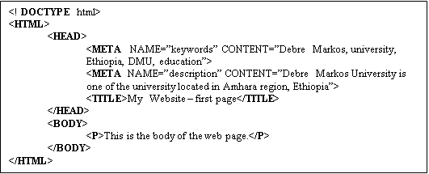
Descriptions of these tags
Tag | Description
<DOCTYPE> | This tag is called a prologue identifier. It does not have to be on a web page and is often omitted. It indicates that the document uses the specified HTML version (in this case, version 5.0, which is the current version)
<HTML> </HTML> | This tag denotes the beginning and end of the web page
<HEAD> </HEAD> | This tag marks the header section of the page – it contains the page title and other information about the document
<META> | Meta tags must be contained within the HEAD tags and are used to provide information about the page that cannot be defined by any other tags. Such information can be extracted by web servers and clients for identifying, indexing and cataloguing documents.  One of the uses of the META tag is to give search engines (like Google, Yahoo) information about the web page. The tags in the code above would mean that if someone searched for any of the ‘keywords’ (Debre Markos, university, Ethiopia, DMU, education) in a search engine, this page would be found. The search engine would show the text for the ‘description’ on the listing of found pages.  Some search engines actively search the web for information – these will pick up the information from the Meta tags. Others allow you to submit information about your web site to them – for example, Yahoo provides a section to suggest a web site. There is also a web site called Submit I! (www.submit-it.com) that allows you to submit your web site to multiple search engines.
<TITLE> </TITLE> | The title tag is used to specify a title for the page. This title will display in the browser’s title bar when the web page is displayed in a browser. The title should be consistent across all the pages in a web site – so that as a user can see in the title bar and the Windows task bar what site they are on. The title should also indicate what part of the site the page is in e.g. ‘Debre Markos University – Departments’
<BODY> </BODY> | the body section is the part of the page that a user will see in a browser – it contains all the text, images etc that make up the page content, along with HTML tags to format the text. It can also be used to specify attributes that affect the whole page e.g. the background colour

HTML, HEAD, TITLE and BODY Tags are html main tags that are used to construct an html skeleton / structure. To develop the webpage, it is possible to use different webpage editors/ plain text editor or any advance editor. Whatever the use of the text editor the structure of basic HTML code/ tags is similar as shown above.
The total code is divided into two parts and both the parts are kept inside <html> tags. The first part is header part, which is optional, and the second one is body part which is the main part.
Any html code should start with <html> and should end with </html>. The header part should starts with <head> and ends with </head>, after this the body part starts with <body> and ends with </body> tag. Inside the body tag, we keep all our content which we want to display to webpage users. Whatever we place in this part of the page will be displayed by the browser to the web users.
The text or tags what goes inside the head tags will not be displayed in the browser window. Inside this tag we keep all the meta keyword tags used for search engines. One of the important tags is title tag and written as <title> title of the webpage</title> tag. Title tags are displayed at the top left side of the browser window. Title tags are also important for our search engine point of view. It is possible to keep most important keywords inside the title tag.
Html developers place web contents in between open and close body tags to display for visitors. So go on filling this place with content to show to the web user. Hence, the purpose of the <body> tag is to define the HTML element that contains the body of the HTML document.
The font of documents in between body tags could be changes using Font tags. It uses to change the way text looks by changing its font, size, colour and emphasis. Written as <font> </font>. It use different key words such as size, color, face, etc.
HTML common Elements and their Descriptions: - There are some Common html tags because some text may be more important than others.
Tag Description
<h1> to <h6> Defines header 1 to header 6
<p> Defines a paragraph
<br> Inserts a single line break
<hr> Defines a horizontal rule
<!--> Defines a comment
- HTML HEADING:- HTML provides six headers, called header elements, for specifying the relative importance of information
– <h1> … </h1>, <h2> … </h2> to <h6> … </h6>
It is assumed the text in <h1> is more important than that in <h2>, <h2> is more important than <h3> and so on so forth based on the size of the text by taking the more important is bigger text. See the following example:-
<html>
<head>
<title>Internet and WWW How to Program Headers</title>
</head>
<body>
<h1>Level 1 Header</h1>
<h2>Level 2 header</h2>
<h3>Level 3 header</h3>
<h4>Level 4 header</h4>
<h5>Level 5 header</h5>
<h6>Level 6 header</h6>
</body>
</html>
The output will be:-
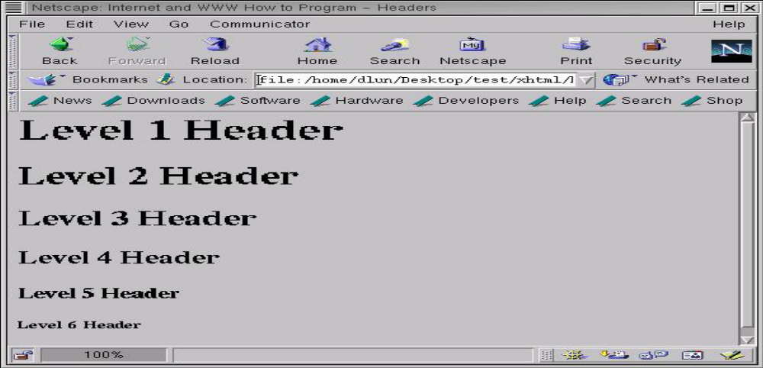
As seen above Starting with <h1> which displays the most prominent font size and ending with <h6> the least prominent font size.
- Paragraph tag:- Paragraphs are defined with the <p> tag to separate paragraphs i.e adds an extra blank line before and after a paragraph tags
Example: <p> This is the start of a very small paragraph. p>
It may use attributes like align (values can be left, right, center, justify). For example; <p align="left">This is a paragraph</p>
- LINE BREAK TAG:-
- The <br> tag forces a line break wherever we place it. It uses to start new line.
- The <br> tag is an empty tag. It has no closing tag.
- comment in HTML:-
- Used to enter a comment in HTML source code.
- The comment will be ignored by the browser.
Example : <!-- This is a comment -->
- Horizontal tag:-
- Used to delimit the parts by display a horizontal line.
- Written as <hr>
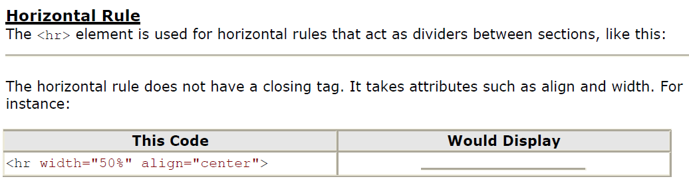
In html, horizontal tag may have attribute with not value as exceptional. But other attributes should have values. Example:- <hr noshade> or <hr noshade="noshade" /> indicates that there should be no shading applied to this horizontal rule. Example:- write an html code that enables to display the following sample webpage:
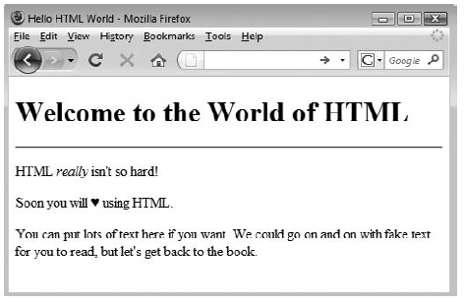

See the following HTML tags and their descriptions:-
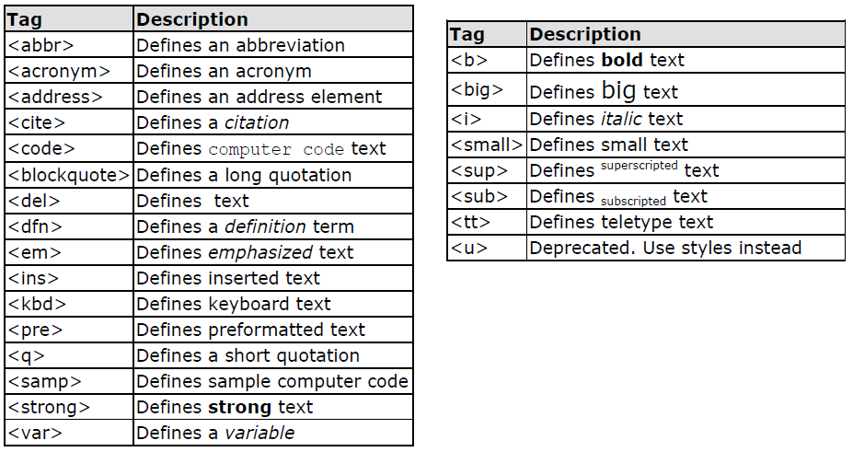
Character tags like <strong> and <em> produce the same physical display as <b> and <i> but are more uniformly supported across different browsers.

HTML ATTRIBUTES
An attribute is used to define the characteristics of an element and is placed inside the element's opening tag. The <tag> tells the browser to do something, while the attribute tells the browser how to do it. For instance, if we add the bgcolor attribute, we can tell the browser that the background color of the page should be blue, like this: <body bgcolor="blue">.
All attributes are made up of two parts: a name and a value.
- The name is the property that wanted to be set. For example, the <font> element in the example carries an attribute whose name is face, which we can use to indicate which typeface one want the text to appear in.
- The value is what we want the value of the property to be. The first example was supposed to use the Arial typeface, so the value of the face attribute is Arial
<font face="arial" color="green">
Many HTML tags have a unique set of their own attributes. Right now we want to focus on a set of generic attributes that can be used with just about every HTML Tag in existence.
Core Attributes: The four core attributes that can be used on the majority of HTML elements (although not all) are: id, title, class and style.
- The id Attribute: The id attribute can be used to uniquely identify any element within a page (or style sheet).
There are two primary reasons that we might want to use an id attribute on an element:
- If an element carries an id attribute as a unique identifier it is possible to identify just that element and its content.
- If there are two elements of the same name within a Web page (or style sheet), the id attribute uses to distinguish between elements that have the same name.
<p id="html">This para explains what is HTML</p>
<p id="css">This para explains what is Casecading Style Sheet</p>
- Title Attributes: - The title attribute gives a suggested title for the element. They syntax for the title attribute is similar as explained for id attribute. The behavior of this attribute will depend upon the element that carries it, although it is often displayed as a tooltip or while the element is loading.
<h4 title="Hello HTML!">Titled Heading Tag Example</h4>
- The class Attribute: The class attribute is used to associate an element with a style sheet, and specifies the class of element. For example: class="className1 className2 className3"
- The style Attribute: The style attribute allows to specify CSS/ casecade style sheet, we discussed in chapter 3, rules within the element. For example: <p style="font-family:arial; color:#FF0000;">Some text...</p>
Note that:-
- Attributes provide additional information about an element
- Attributes are always specified in the start tag
- Attributes and attribute values are case-insensitive.
- Attributes come in name/value pairs like: name="value“, but not always
- Attribute values better be enclosed in double quotes.

Attributes of Body tag
The attributes you can set for the page in the BODY tag are as follows:
You can set page-level properties in the BODY tag. Some of these are listed in the table below

Attribute | Description & Sample values
BACKGROUND | Background image – the specified image will be tiled across the page. If you do not want the image to tile, you can try to size the image (using a graphics package such as PhotoShop) so that it fills one page  e.g. <BODY background=”bgImage.gif”>
BGCOLOR | Background colour – colours in HTML can be specified by name – but the name must be one of the set of reserved names (red, blue, green etc – see the HTMLib Reference for a full list - navigate to the section about the BODY tag, then find the section about BGCOLOR).  Alternatively, a colour can be specified by a value. The value uses a combination of three pairs of hexadecimal numbers. Each pair represents the amount of red, green and blue in the colour. The value must be preceded by a #. For example, black is #000000, white is #ffffff.  See section Error: Reference source not found (below) about Using Colours in Web Pages for more information.  e.g. <BODY bgcolor=”red”>  or <BODY bgcolor=”#
TEXT | Text colour – specifies the colour for all text that does not have a colour specified otherwise.  e.g. <BODY text=”green”>
LINK, VLINK, ALINK (ALINK only applies on Netscape browsers) | Link colours – the colours for links, visited links and active links can be specified (a link is active while it is being clicked on – this colour will only apply on Netscape browsers)  <BODY link="red" vlink="green" alink="blue">
TOP MARGIN, LEFT MARGIN, RIGHT MARGIN,  BOTTOMMARGIN | Setting the margins – the left, right, top and bottom margins of the page can be specified, in pixels; the margins are relative to the sides of the browser window. It is usual to set the top and left margins so that the page does not appear to be flush with the top left corner of the browser  <BODY top margin="30" bottom margin="30" left margin="30" right margin="30">

Example: - From <body bgcolor=”green”> sample example, bgcolor is the name of attribute, green is the value of the attribute.
- Bgcolor :- The bgcolor attribute specifies a background-color for an HTML page. The value of this attribute can be a hexadecimal number, an RGB value, or a color name: <body bgcolor="#000000"> <body bgcolor="rgb(0,0,0)"> <body bgcolor="black"> The lines above all set the background-color to black
- Background: - The background attribute can also specify a background-image for an HTML page. The value of this attribute is the URL of the image you want to use. If the image is smaller than the browser window, the image will repeat itself until it fills the entire browser window. See the following:-
- <body background="clouds.gif"> <body <body
- <background="http://profdevtrain.austincc.edu/html/graphics/clouds.gif">
- Text=”,… ”
  - To determine the text color for a webpage. The value of the text attribute can be red, green, blue etc.
- Anchor tag attributes: anchor tag, <a>, uses to make hyperlink.
  - link=”…”
    - To determine the color of hyperlinks on a webpage.
  - vlink=”…”
    - To determine the color of visited hyperlinks on a webpage
  - alink= “ ”
    - To determine the color of active hyperlinks on a webpage
There are HTML tags that are used to defines a lot of elements for formatting output, like bold, italic text, bold-italic, superscript, subscript, small text, strong and so on.
Example:-

Tag Description
<b> Defines bold text
<big> Defines big text
<em> Defines emphasized text
<i> Defines italic text
<small> Defines small text
<strong> Defines strong text
<sub> Defines subscripted text
<sup> Defines superscripted text
<ins> Defines inserted text
<del> Defines deleted text
<s> Deprecated. Use <del> instead
<abbr> Defines an abbreviation
<acronym> Defines an acronym
<address> Defines an address element
<bdo> Defines the text direction
<q> Defines a short quotation
<cite> Defines a citation
<dfn> Defines a definition term

- Text direction attribute: - use <bdo dir=value>. It uses to demonstrate how to change the text direction. The value of dir attribute can be rtl or ltr.
<html>
<body>
<p> If your browser supports bi-directional override (bdo), the next line will be written from the right to the left (rtl):</p>
<bdo dir="rtl">Here is some Hebrew text</bdo>
</body>
</html>
- Quotations:- This example demonstrates how to handle quotations
<html>
<body>
<q> This is a long quotation</q>
<body>
</html>

- Deleted and inserted text: - These are tags that are used to mark a text that is deleted or inserted to a document. See the following example:
<html><body>
<p>a dozen is <del>twenty</del>
<ins>twelve</ins> pieces</p>
<p> Most browsers will overstrike deleted text and underline inserted text.</p>
<p>Some older browsers will display deleted or inserted text as plain text.</p>
</body></html>
- Abbreviations and acronyms: - These tags use for handle an abbreviation or an acronym as written below.
<html><body>
<abbr title="United Nations">UN</abbr><br>
<acronym title="World Wide Web">WWW</acronym>
</body></html>
- HTML Character Entities: - Some characters like the < character, have a special meaning in HTML, and therefore cannot be used in the text. To display a less than sign (<) in HTML, we have to use a character entity.
A character entity has three parts: an ampersand (&), an entity name or a # and an entity number, and finally a semicolon (;).
To display a less than sign in an HTML document we must write: &lt; or &#60;
- Advantage of using a name: name is easier to remember.
- Disadvantage: not all browsers support the newest entity names, while the support for entity numbers is very good in almost all browsers.
Note That:- The entities are case sensitive
- Non-breaking Space: - The most common character entity in HTML is the non-breaking space. Normally HTML will truncate spaces in the text. If we write 10 spaces in the text, HTML will remove 9 of them. To add spaces to text, use the &nbsp; character entity. The following shows the description of lists of entity and non-breaking spaces
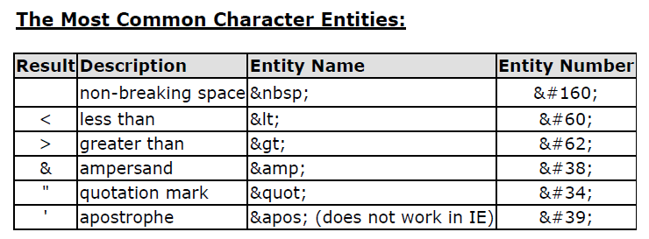Some Other Commonly Used Character Entities:
Result Description Entity Name Entity Number
¢ cent &cent; &#162;
£ pound &pound; &#163;
¥ Yen &yen; &#165;
€ euro &euro; &#8364;
§ section &sect; &#167;
© copyright &copy; &#169;
® registered trademark &reg; &#174;
× multiplication &times; &#215;
÷ division &divide; &#247;
A character entity has three parts: an ampersand (&), an entity name or an entity number, and finally a semicolon (;). The & means we are beginning a special character, the; means ending a special character and the letters in between are sort of an abbreviation for what it's for.
  - HTML Links/ Hyperlinks
Links are extremely useful for bringing the user to another page that may be within website, or may be another website that may useful to others. HTML uses a hyperlink to link to another document on the Web. A hyperlink (or link) is a word, group of words, or image that can be clicked on to jump to a new document or a new section within the current document. To create a link to another document, the hyperlink attribute uses the “href” attribute.
An anchor can point to any resource on the Web: an HTML page, an image, a sound file, a movie, etc. The HTML code for a link is simple, written as follow: - <a href="url">Link text</a>.

The <a> tag is used to create an anchor or link to link from, the href attribute is used to tell the address of the document or page we are linking to, and the words between the open and close of the anchor tag will be displayed as a hyperlink. When we click on the displayed linker word(s), the browser will jump to the actual documents, URL. As shown from above hyperlink syntax,
- href: Means Hypertext REFerence. The href part is the attribute, with the location of the other page as its value.
- The href attribute specifies the destination of a link.
- The href or the name attribute must be present in the <a> tag.
- The href attribute is supported in all major browsers.
The name attribute is used to create a named anchor. When using named anchors we can create links that can jump directly to a specific section on a page, instead of letting the user scroll around to find what he/she is looking for. Unlike an anchor that uses href, a named anchor doesn't change the appearance of the text (unless we set styles for that anchor) or indicate in any way that there is anything special about the text. For example vlink and alink attributes.
To link directly to the top section, add a # sign and the name of the anchor to the end of a URL as:-
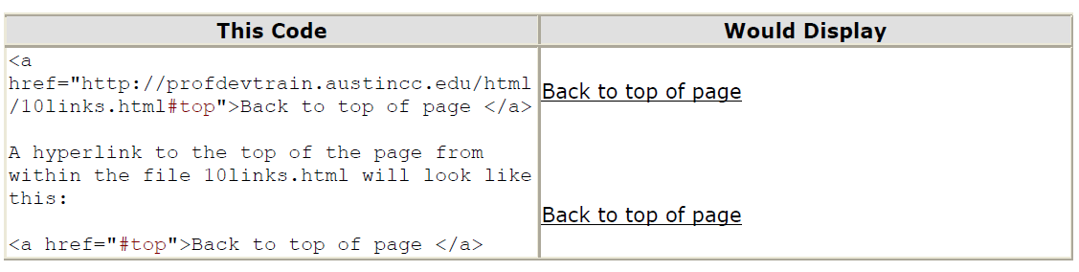

In addition to href attribute, there are <a> tag attributes such as name and target attributes. An attribute called TARGET has values like "_blank" | "_parent" | "_self" | "_top" | window name
TARGET: - Controls where the new document will be displayed when the user follows a link. TARGET, the new document open in a new window, or if we are using frames, in another frame.
TARGET = "_blank"
  - Used to opens the new document in a new window.
  - < A HREF="newwindow.html" TARGET="_blank">a new window</A>
  - This value does not require the use of any frames.
TARGET = "_parent"
  - Used in the situation where a frameset file is nested inside another frameset file.
  - A link in one of the inner frameset documents which uses "_parent" will load the new document where the inner frameset file had been.
  - For example, this anchor <A HREF="bigframe.html" TARGET="_parent"> bigframe </A>

TARGET = "_self"
- "_self" puts the new document in the same window and frame as the current document.
- "_self" works the same as if not used TARGET at all.
- For example <A HREF="selftarget.html" TARGET="_self">next</A> page
TARGET = "_top"
- "_top" loads the linked document in the topmost frame... that is, the new page fills the entire window.
- For example,<A HREF="selftarget.html" TARGET="_top">top</A>
N.B:- We can create an image hyperlink as follows:-
<a href=“page1.html”>
<img src=“image.gif” />
</a>
  - HTML Images
In HTML, images are defined with the <img> tag, to display the image on a page/ webpage. We use “src” attribute which stands for "source". The value of the src attribute is the URL of the image we want to display. Syntax for defining an image is <img src="url" alt="some_text"/>
The required alt attribute specifies an alternate text for an image, if the image cannot be displayed. The value of the alt attribute is an author-defined text: <img src="pulpit.jpg" alt="Pulpit rock" width="304" height="228" >. The height and width attributes are used to specify the height and width of an image.
Example:-
<html>
<body>
<h1 align="center">My First Web page</h1>
<p>Welcome to my first webpage.</p>
<p>By learning html, I'll be able to create web pages<br>
which I am of course.</p>
<!-- Who would have guessed how easy this would be -->
<p>
<img src="graphics/chef.gif" width="130" height="101" alt="Smiling Happy Chef" align="center">
</p>
<p align="center">This is my Chef</p>
</body>
</html>
The most common options are:
- SRC="FILENAME" - Specifies the SOURCE of the image; if the image file is in the same directory as the source document, all that is needed is the filename itself. Note: Don't link to another page for an image - copy the image to the file space and link to it from there.
- HEIGHT="NUMBER" - Specifies that the height of the image should be NUMBER pixels
- WIDTH="NUMBER" - Specifies that the width of the image should be NUMBER pixels. If no dimensions are specified for the image, the browser will insert the image exactly as is, at the same size as developers would view it in a picture editor on computer. The picture will load slightly faster if you specify the height and width so that the browser does not have to determine it.
- ALT="DESCRIPTION" - Specifies a description of the image. The ALT option for the IMG tag is useful for those whose browsers cannot support in-line images, or have their images turned off in their browsers; instead of seeing the image, they'll see the description of the image that we gave them in the ALT tag.
- BORDER="NUMBER" - Specifies the width of the image's border, in pixels.
- Hspace and vspace also used to assign the horizontal and vertical spacing between images
Example:- An image tag could look like: <img src = "filename" height = "number" width = "number" alt = "description" border = "number"> like <img vspace="10" hspace="30" src="freenetlogo.gif" WIDTH="281" HEIGHT="108">
  - VIDEO/ Audio TAGS:-
To insert video, use a <video> tag and set its src attribute to a local or remote URL containing a playable movie. The play black can be displayed using controls by including the “controls” attribute, as well as set the dimensions of the movie to its natural size:-
<video src=http://htmlref.com/ch2/html_5.mp4 width="640" height="360" controls>
<Strong>HTML5 video element not supported</strong>
</video>
HTML’s audio element is quite similar to the video element. The element should support common sound formats such as WAV files:
<audio src=http://htmlref.com/ch2/music.wav controls></audio> or
<audio>
<bgsound src=http://htmlref.com/ch2/music.wav controls>
</audio>
A complete example is shown here:
<html>
<body>
<h1>Simple Audio Examples</h1>
<h2>wav Format</h2>
<video src=”a.mp4” controls/>
<audio src="http://htmlref.com/ch2/music.wav" controls></audio>
<h2>ogg Format</h2>
<audio src="http://htmlref.com/ch2/music.ogg" controls></audio>
<h2>Multiple Formats and Fallback</h2>
<audio controls autobuffer autoplay>
<source src="http://htmlref.com/ch2/music.ogg" type="audio/ogg">
<source src="http://htmlref.com/ch2/music.wav" type="audio/wav">
<!--[if IE]>
<bgsound src="http://htmlref.com/ch2/music.wav">
<![endif]-->
</audio>
</body>
</html>
- Audio and video can also displayed by a tag called <embed>. It is written as <embed src=url>…<embed>
  - HTML Framesets
With frames, it is possible to display more than one Web page in the same browser window. It uses to partition a window into independent parts (frames) and used to display different documents in different frame with single interface.
The <frameset> tag defines how to divide the window into frames. Each frameset defines a set of rows or columns. The values of the rows/columns indicate the amount of screen area each row/column will occupy.
Common frameset tags are:
Tag Description
<frameset> Defines a set of frames, container tag type
<frame> Defines a sub window (a frame). It is empty tag type.
Used to display document.

Two types of frameset:-
- Vertical frameset:-demonstrates how to make a vertical frameset with different documents.
<html>
<frameset cols="25%, 50%, 25 %">
<frame src="framea.htm">
<frame src="frameb.htm">
<frame src="framec.htm">
</frameset>
</html>
- Horizontal frameset: - demonstrates how to make a horizontal frameset with different documents.
<html><frameset rows="25%,50%,25%">
<frame src="framea.htm">
<frame src="frameb.htm">
<frame src="framec.htm">
</frameset></html>
Frames can divide the screen into separate windows. Each of these windows can contain an HTML document. A file that specifies how the screen is divided into frames is called a frameset. The content model says that the <frameset> tag contains one or more <frame> tags, which are used to indicate the framed contents. A <frameset> tag also might contain a <noframes> tag, whose contents will be displayed by browsers that do not support frames
There are few drawbacks of frames:-
- Some browsers do not print well from framesets.
- Some smaller devices cannot cope with frames, often because their screen is not big enough to be divided up.
- Some time the page will be displayed differently on different computers due to different screen resolution.
- The browser's back button might not work as the user hopes.
- There are still few browsers who do not support frame technology.
If needed to make a homepage that uses frames, we should use the followings:
- Make an HTML document with the frameset
- Make the normal HTML documents that should be loaded into each of these frames.
When a frameset page is loaded, the browser automatically loads each of the pages associated with the frames. Each HTML document is called a frame, and each frame is independent of the others.
The frameset element holds two or more frame elements. Each frame element holds a separate document. The frameset element states only HOW MANY columns or rows there will be in the frameset and it uses <frameset> tag. The <frame> tag defines one particular window (frame) within a frameset. In the example below we have a frameset with two columns. The first column is set to 25% of the width of the browser window. The second column is set to 75% of the width of the browser window. The document "framea.htm" is put into the first column, and the document "frameb.htm" is put into the second column:
<frameset cols="25%,75%">
<frame src="framea.htm" />
<frame src="frameb.htm" />
</frameset>
Note:
- The frameset column size can also be set in pixels (cols="200,500"), and one of the columns can be set to use the remaining space, with an asterisk (cols="25 %,*").
- No use the body element together with the frameset element. However, if <noframes> tag is added containing some text for browsers that do not support frames, it is possible to enclose the text in a body element.
Attributes of frame
Attribute | Value | Description
frameborder | 0 or 1 | Specifies whether or not to display a border around a frame
marginheight | Pixels | Specifies the top and bottom margins of a frame
marginwidth | Pixels | Specifies the left and right margins of a frame
noresize | Noresize | Specifies that a frame cannot be resized
scrolling | Yes, no  auto | Specifies whether or not to display scrollbars in a frame
src | URL | Specifies the URL of the document to show in a frame
Attributes of frameset
Attribute | Value | Description
cols | Pixels, % or  * | Specifies the number and size of columns in a frameset
rows | Pixels, % or  * | Specifies the number and size of rows in a frameset

Nested Frames
Framesets may be nested to any level. In the following example, the outer FRAMESET divides the available space into three equal columns. The inner FRAMESET then divides the second area into two rows of unequal height.
Example: 1
<FRAMESET cols="33%, 33%, 34%">
<frame src=”one.html”>
<FRAMESET rows="40%, 50%">
<frame src=”two.html”>
<frame src=”three.html”>
</FRAMESET>
<frame src=”four.html”>
</FRAMESET>
Example 2:-
<HTML>
<HEAD>
<TITLE>A simple frameset document</TITLE>
</HEAD>
<FRAMESET cols="20%, 80%">
<FRAMESET rows="100, 200">
<FRAME src="contents_of_frame1.html">
<FRAME src="contents_of_frame2.gif">
</FRAMESET>
<FRAME src="contents_of_frame3.html">
<NOFRAMES>
<P>This frameset document contains:
<UL>
<LI><A href="contents_of_frame1.html">Some neat contents</A>
<LI><IMG src="contents_of_frame2.gif" alt="A neat image">
<LI><A href="contents_of_frame3.html">Some other neat contents</A>
</UL>
</NOFRAMES>
</FRAMESET> </HTML>
Note: the more frames are nested; it will make it complicated hence difficult manageable.
NOFRAMES:-
The NOFRAMES element specifies content that should be displayed only by user agents that do not support frames or are configured not to display frames. User agents that support frames must only display the contents of a NOFRAMES declaration when configured not to display frames. User agents that do not support frames must display the contents of NOFRAMES in any case. NOFRAMES may be used at the end of the FRAMESET section of the document.
a <body> tag should be found for browsers that do not support frames. A visual representation of this idea is shown here:
Example1:- <!DOCTYPE HTML PUBLIC "-//W3C//DTD HTML 4.01 Frameset//EN"
"http://www.w3.org/TR/html4/frameset.dtd">
<HTML>
<HEAD>
<TITLE>A frameset document with NOFRAMES</TITLE>
</HEAD>
<FRAMESET cols="50%, 50%">
<FRAME src="main.html">
<FRAME src="table_of_contents.html">
<NOFRAMES>
<P>Here is the <A href="main-noframes.html">
non-frame based version of the document.</A>
</NOFRAMES>
</FRAMESET>
</HTML>

Example 2:- 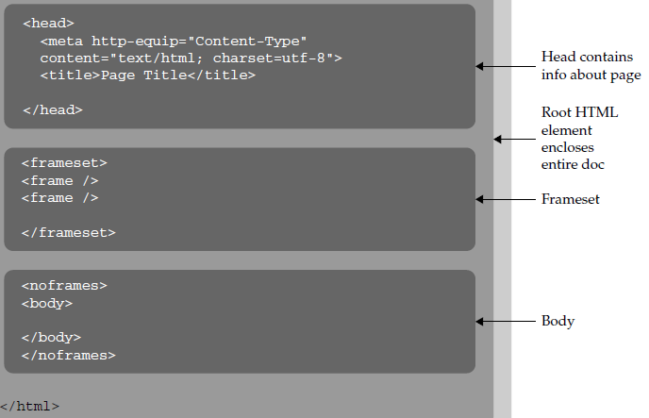

Noframes compatibility
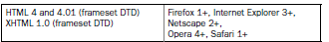

IFRAME - Inline Frames
The IFRAME element allows authors to insert a frame within a block of text. Inserting an inline frame within a section of text is much like inserting an object via the OBJECT element: they both allow to insert an HTML document in the middle of another, they may both be aligned with surrounding text, etc.
The information to be inserted inline is designated by the src attribute of this element. The contents of the IFRAME element, on the other hand, should only be displayed by user agents that do not support frames or are configured not to display frames.
The <iframe> tag is not used within a <frameset> tag. Instead, it appears anywhere in the document. The <iframe> tag defines a rectangular region within the document in which the browser displays a separate document, including scrollbars and borders.
<body>
...other document content...
<iframe src="/html/menu.htm" width="75" height="200" align="right">
Your browser does not support inline frames. To view this
<a href="/html/menu.htm">document</a> correctly, you'll need
a copy of Internet Explorer or the latest Netscape Navigator.
</iframe>
...subsequent document content...
</body>
For user agents that support frames, the following example will place an inline frame surrounded by a border in the middle of the text.
<IFRAME src="foo.html" width="400" height="500"
scrolling="auto" frameborder="1">
[Your user agent does not support frames or is currently configured
not to display frames. However, you may visit
<A href="foo.html">the related document.</A>]
</IFRAME>
  - HTML Tables
Tables are defined with the <table> tag. A table is divided into rows (with the <tr> tag), and each row is divided into data cells (with the <td> tag). td stands for "table data," and holds the content of a data cell. A <td> tag can contain text, links, images, lists, forms, other tables, etc. Header information in a table is defined with the <th> tag. The text in a th element will be bold and centered.
Tags Description
<Table> Defines a table
<th> Defines a table header
<tr> Defines a table row
<td> Defines a table cell
<caption> Defines a table caption
<colgroup> Defines groups of table columns
<col> Defines the attribute values for one or more columns in a table
Example:
<table border="1">
<tr>
<th>Header 1</th>
<th>Header 2</th>
</tr>
<tr>
<td bgcolor=green>row 1, cell 1</td>
<td bgcolor=red>row 1, cell 2</td>
</tr>
<tr>
<td>row 2, cell 1</td>
<td>row 2, cell 2</td>
</tr>
</table>
HTML code above looks in a browser:
Header 1 | Header 2
row 1, cell 1 | row 1, cell 2
row 2, cell 1 | row 2, cell 2

Tables’ attribute
Border: - If no specify a border attribute to the table, it will be displayed without any borders. Sometimes this can be useful, but most of the time, we want the borders with value of some number.
<table border="n">
Headings in a table: demonstrates how to display table headers. <html><body><h4> Table headers:
- Non break space: to use "&nbsp;" to handle cells that have no content.
- Table with a caption: demonstrates a table with a caption
- Cell padding: to create more white space between the cell content and its borders.
- CELLSPACING: controls the space between table cells. Although there is no official default, browsers usually use a default of 2.
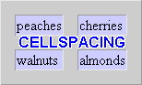

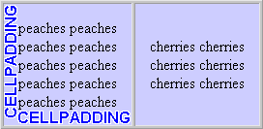
- CELLPADDING: sets the amount of space between the contents of the cell and the cell wall. The default is 1. CELLPADDING is usually more effective than CELLSPACING for spreading out the contents of the table

Attributes of table: the attributes of a table will be applied on the whole table element which include one or more rows (<tr>), header cells (<th>) or data cells (<td>)
Attribute | Value | Description
align | left  center  right | Specifies the alignment of a table according to surrounding text
bgcolor | rgb(x,x,x)  #xxxxxx  colorname | Specifies the background color for a table
border | Pixels | Specifies the width of the borders around a table
cellpadding | Pixels | Specifies the space between the cell wall and the cell content
cellspacing | Pixels | Specifies the space between cells
width | pixels  % | Specifies the width of a table
Table 2.1 attributes of table

Attributes of rows and cells: this attributes will be applicable only to the header cell or the data cell if it is used with <th> or <td> tag while it will affect the whole content of the row if it is used by the <tr> tag.

Attribute | Value | Description
align | left  right  center  justify  char | Aligns the content in a cell
bgcolor | rgb(x,x,x)  #xxxxxx  colorname | Specifies a background color for a cell
colspan | Number | Specifies the number of columns a cell should span
height | pixels  % | Sets the height of a cell
nowrap | Nowrap | Specifies that the content inside a cell should not wrap
rowspan | Number | Sets the number of rows a cell should span
width | pixels  % | Deprecated. Use styles instead.  Specifies the width of a cell
valign | top  middle  bottom | Vertical aligns the content in a table row
Table attributes of rows and cells

COLSPAN and ROWSPAN
Table cells can span across more than one column or row. Any cell ( <th> or <td> tag) can have a rowspan="integer " or colspan=" integer" attribute to “span” more than one cell of the table, that is, place that element's content into an area that would normally be occupied by two or more cells.
The attributes COLSPAN ("how many across") and ROWSPAN ("how many down") indicate how many columns or rows a cell should take up.
- COLSPAN number of columns to cover
- ROWSPAN: number of rows to cover
- WIDTH: width of cell
- HEIGHT: height of cell
- BGCOLOR: color of the background
- BORDERCOLOR: color of border around the table
- ALIGN: horizontal alignment of cell contents
- VALIGN: vertical alignment of cell contents
- VSPACE: vertical space between table and surrounding text
- HSPACE: horizontal space between table and surrounding text
- RULES: if there should be internal borders
Example: - write html code to display the following web page


Nesting Tables
Tables may be nested to produce interesting effects, such as the following example: Because the TABLE element must have an end tag, no particular tricks exist for nesting tables. we may include a table within another table’s cell or another table’s row
Table nest example:
<TABLE border=”1” cellspacing=”2”
cellpadding=”2”>
<TR>
<TD colspan=”3”>A1
<TR>
<TD>B1
<TD>B2
<TD rowspan=”2”>B3
<TR>
<TD colspan=”2”>C1
</TABLE>

To add a title to a table, place the caption text between <caption> and </caption> tags just after the <table> tag. The align="bottom" attribute in the <caption> can be added. Table tag may have width attribute with value in persent or inch as <table width="75 %">&hellip;</table> or <table width="5.5in">...</table>

<html>
<body>
<TABLE border=”5” cellspacing=”2”
cellpadding=”5” bgcolor=red>
<caption>Ethiopian table</caption>
<tr>
<th colspan="3" align="center">Lifespan</th>
<th>top</th>
</tr>
<tr>
<td>Name
<td>Born
<td>hhhh
<td>Died
</tr>
<tr><td>25
<td>1900
<td>&nbsp;
<td>1971
</tr>
</table>
</body>
</html>
  - HTML Lists
It uses to list down sets of documents with sequence of numbers of bullets of combination of the two. The followings are html List Tags
Tag Description
<ol> Defines an ordered list
<ul> Defines an unordered list
<li> Defines a list item
<dl> Defines a definition list
<dt> Defines a definition term
<dd> Defines a definition description
<dir> Deprecated. Use <ul> instead
<menu> Deprecated. Use <ul> instead
Different types of html lists:-
- Unordered Lists: - An unordered list starts with the <ul> tag. Each list item starts with the <li> tag. The list items are marked with bullets (typically small black circles). The “type” attribute can be used to specifies the style of the bullet points of the list items, its value includes disc, square and circle.
Example:-
<html>
<body>
<h4>Disc bullets list:</h4>
<ul type="disc">
<li>Apples</li>
<li>Bananas</li>
<li>Lemons</li>
<li>Oranges</li <html><body>
- Order List:- An orderlist use <ol> tag type with attribute of “1”, “a”, “i” etc which are grouped under number types.
<html>
<body>
<h4>Numbered list:</h4>
<ol type=A>
<li>Apples</li>
<li>Bananas</li>
<li>Lemons</li>
<li>Oranges</li> </ol>
Each list item starts with the <li> tag to lists down with sequences
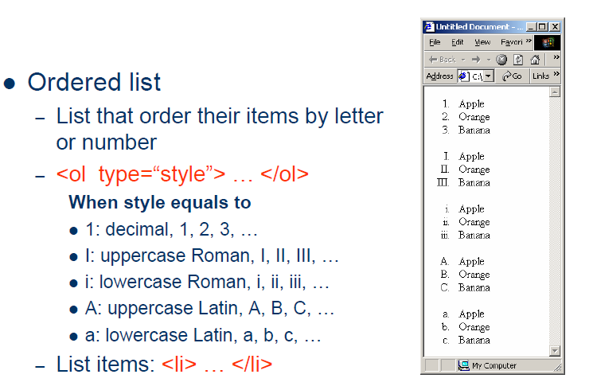
- Definition Lists :- A definition list is not a list of items. This is a list of terms and explanation of the terms. A definition list starts with the <dl> tag. Each definition-list term starts with the <dt> tag. Each definition-list definition starts with the <dd> tag.
<dl>
<dt>Coffee</dt>
<dd>Black hot drink</dd>
<dt>Milk</dt>
<dd>White cold drink</dd>
</dl>
Here is how it looks in a browser: Coffee Black hot drink Milk White cold drink Inside a definition-list definition (the <dd> tag) you can put paragraphs, line breaks, images, links, other
  - HTML FORM
The <form> tag is used to create an HTML form for user input. A form can contain input elements like text fields, checkboxes, radio-buttons, submit buttons and more. A form can also contain select menus, textarea, fieldset, legend, and label elements.
HTML forms are used to pass data to a server. An HTML form is a section of a document containing normal content, markup, special elements called controls (checkboxes, radio buttons, menus, etc.), and labels on those controls. Users generally "complete" a form by modifying its controls (entering text, selecting menu items, etc.), before submitting the form for further processing (e.g., to a Web server, to a mail server, etc.). Forms are a vital tool for the webmaster to receive information from the web server, such as: their name, email address, credit card, etc. A form will take input from the viewer and depending on needs; we may store that data into a file, place an order, gather user statistics, register the person to our web forum, or maybe subscribe them to our weekly newsletter.

The <form> tag is used to create an HTML form:
<form>
input elements
</form>
The most important form element is the input element. The input element is used to select user information. An input element can vary in many ways, depending on the type attribute. An input element can be of type text field, checkbox, password, radio button, submit button, and more. Elements inside a form are introduced by the
<input> tag.
The <input> tag may use the following attributes as values:-
– type=“hidden” name=“variable name” value=“value that sends to the server”
– type =“text” name=“” value =“” size=“25”
– type =“submit” value =“”
– type =“reset” value =“”
– type =“checkbox” value =“” name=“”

Working with Text Fields and Passwords
Text Field
Declared as <input type="text" /> defines a one-line input field that a user can enter text into. See example:-
<form>
First name: <input type="text" name="firstname" /><br />
Last name: <input type="text" name="lastname" />
</form>
The output will look as:
Top of Form
First name: 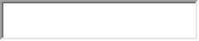
Last name:
Note: The form itself is not visible. Also note that the default width of a text field is 20 characters.
Password
Written as <input type="password" /> defines a password field. See example as
<form>
Password: <input type="password" name="pwd" />
</form>
The output looks as:
Top of Form
Password: 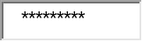
Note: the characters entered in to the password field are masked.
Bottom of Form

Using Buttons, Checkboxes and Selection Lists
Radio Buttons:-
- Radio buttons are a popular form of interaction. we may have seen them on quizzes, questionnaires, and other web sites that give the user a multiple choice question. Below are a couple attributes you should know that relate to the radio button.
  - Value: specifies what will be sent if the user chooses this radio button. Only one value will be sent for a given group of radio buttons.
  - Name: defines which set of radio buttons that it is a part of.
- Written as <input type="radio" /> defines a radio button. Radio buttons let a user select ONLY ONE of a limited number of choices: see example
<form>
<input type="radio" name="sex" value="male" /> Male<br />
<input type="radio" name="sex" value="female" /> Female
</form>

Checkboxes
- Check boxes allow for multiple items to be selected for a certain group of choices. The check box's name and value attributes behave the same as a radio button.
- Written as <input type="checkbox" /> defines a checkbox. Checkboxes let a user select ONE or MORE options of a limited number of choices.
<form>
<input type="checkbox" name="vehicle" value="Bike" /> I have a bike<br />
<input type="checkbox" name="vehicle" value="Car" /> I have a car
</form>

Example:-
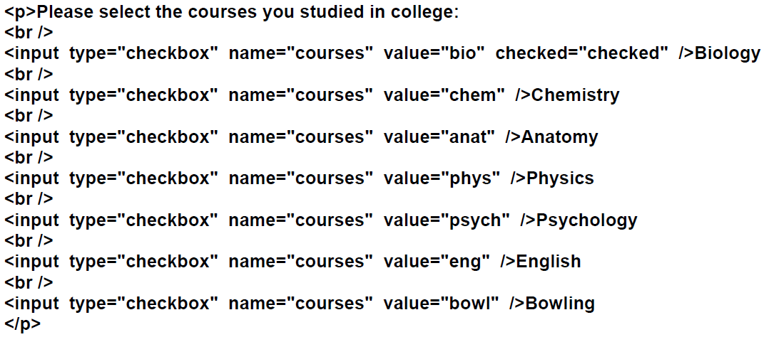
Selection lists
- Drop down menus are created with the <select> and <option> tags. <select> is the list itself and each <option> is an available choice for the user.
<select name="degree">
<option>Choose One</option>
<option>Some High School</option>
<option>High School Degree</option>
<option>Some College</option>
<option>Bachelor's Degree</option>
<option>Doctorate</option>
<input type="submit" value="Email Yourself">
</select>

Example 2:-
Favorite language:
<SELECT NAME="language">
<OPTION VALUE="c">C
<OPTION VALUE="c++">C++
<OPTION VALUE="java" SELECTED>Java
<OPTION VALUE="lisp">Lisp
<OPTION VALUE="perl">Perl
<OPTION VALUE="smalltalk">Smalltalk
</SELECT>

The followings are some of the common select attributes:-
Attribute | Value | Description
disabled | Disabled | Specifies that a drop-down list should be disabled
multiple | Multiple | Specifies that multiple options can be selected
name | Name | Specifies the name of a drop-down list
size | Number | Specifies the number of visible options in a drop-down list

Text Area Tags:-
- It uses to create an area in our form, where visitors can enter longer answers such as entering an abstract or essay. Here, visitors can enter up to 32, 700 characters in a text area.
- It is aritten as <textarea>…..</textarea> to create input area
- The text area tag has several attributes such as name, rows, cols and wrap.
- See the following example:-
<textarea name=”abstract” rows=”10” cols=”70” wrap=”wrap”>
</textarea>
Where
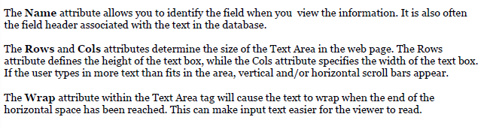
Example:-
<p>please comment the document what I sent before:-<br>
<textarea name=”selfdescribition” rows=”10” cols=”80” wrap=”wrap”>
</textarea>
</p>

Example:-
<html>
<body>
<textarea name=”abstract” rows=”100” cols=”170” wrap=”wrap”>
</textarea>
<input type="text" value="enteryour comment"/>
</body>
</html>

Example:-
<CENTER>
<P>
Enter some HTML:<BR>
<TEXTAREA NAME="HTML" ROWS=5 COLS=30>
Delete this text and replace
With some HTML to validate.
</TEXTAREA>
<CENTER>

Reset button
- The reset buton clears the form and returns all the settings to their defalt values. The attribute value is the text that will appear in the button
- Written as <input type=”reset” value =”reset the form”/>

Linking HTML Forms with PHP Scripts
To create a link between PHP scripts and HTML forms, we need to use the functionalities of buttons, and the attribute of the <form tag>, specifically “action” and “method”.
Buttons:
Submit buttons: When activated, a submit button submits a form. A form may contain more than one submit button.
- Reset buttons: When activated, a reset button resets all controls to their initial values.
- <input type="submit" /> defines a submit button.
A submit button is used to send form data to a server. The data is sent to the page specified in the form's action attribute (how to write scripts will be discussed in the coming chapters).
Action and method:
The file defined in the action attribute usually does something with the received input:
<form name="input" action="action.php" method="get">
Username: <input type="text" name="user" />
<input type="submit" value="Submit" />

Automating Processing: Info Forms and Emails
If we would like to provide our web site visitors with a simple way to contact us from our web site, but really don't want to display our email address, this HTML form code may be what we're looking for. We can create a simple form, as displayed below, to enable our visitors to send us comments, questions, product support requests, or whatever we'd like:-
<form action=mailto:dummy1@yahoo.com, method="POST", enctype="text/plain">
Your Name: <input type="text" size="20" name="VisitorName"><br><br>
Your Comment: <textarea name="VisitorComment" rows="4" cols="20">
</textarea><br><br>
<input type="submit" value="Email This Form">
</form>

Example:-
<input type="hidden" name=“title" value="Feedback" />
<p><label>Name:
<input type= "text" name= "name" size="25" maxlength="30"/>
</label>
</p>
<input type= "submit" value="Submit your entries"/>
<input type= "reset" value="Clear Your Entries"/>
Example
  - Creating File upload
HTML Element: <INPUT TYPE="FILE" ...> (No End Tag). Attributes: NAME (required), VALUE (ignored), SIZE, MAXLENGTH, ACCEPT, ONCHANGE, ONSELECT, ONFOCUS, ONBLUR (nonstandard).

This element results in a filename textfield next to a Browse button. Users can enter a path directly in the textfield or click on the button to bring up a file selection dialog that lets them interactively choose the path to a file. When the form is submitted, the contents of the file are transmitted as long as an ENCTYPE of multipart/form data was specified in the initial FORM declaration.

For multipart data, you also need to specify POST as the method type. This element provides a convenient way to make user-support pages, with which the user sends a description of a problem along with any associated data or configuration files.
It uses attributes as:-
- The NAME attribute identifies the text field to the server-side program.
- VALUE
For security reasons, this attribute is ignored; only the end user can specify a filename. Otherwise, a malicious HTML author could steal client files by specifying a filename and then using JavaScript to automatically submit the form when the page is loaded.
- ONCHANGE, ONSELECT, ONFOCUS, and ONBLUR
These attributes are used by browsers that support JavaScript to specify the action to take when the mouse leaves the textfield after a change has occurred, when the user selects text in the textfield, when the textfield gets the input focus, and when the textfield loses the input focus, respectively.
Example:-
<FORM ACTION="http://localhost:8088/SomeProgram"
ENCTYPE="multipart/form-data" METHOD="POST">
Enter data file below :<BR>
<INPUT TYPE="FILE" NAME="fileName">
<input type="submit" value="upload the file" />
</FORM>
- It uses to upload different files such as word and pdf formats
- See the following example:-
<html>
<body>
<form method="post" action="cgi-bin/upload.cgi" enctype="multipart/form-data">
<p><strong> file upload area</strong></p>
<p>please select the file to upload:<br/>
<input type="file" name="title" size="50"/>
<input type="submit" value="upload the file" />
</body>
</html>
Exercise: Test the output of the following codes

<html>
<body>
<form action="<?php $_PHP_SELF ?>" method="POST">
FName: <input type="text" name="fname" />
LName: <input type="text" name="lname" />
GName: <input type="text" name="gname" />
Department: <input type="text" name="dname" />
College: <input type="text" name="cname" />
Age: <input type="text" name="age" />
<input type="submit" />
</form>
</body>
</html>

<html>
<head>
<title>Personal INFO</title>
</head>
<body>
<form method="post" action=”a.php" > // assume you have a.php in the folder
First Name:<input type="text" size="12" maxlength="12" name="Fname"><br />
Last Name:<input type="text" size="12" maxlength="36" name="Lname"><br />
Gender:<br />
Male:<input type="radio" value="M" name="gender"><br />
Female:<input type="radio" value="F" name="gender"><br />
Please choose type of residence:<br />
Steak:<input type="checkbox" value="Steak" name="food"/><br />
Pizza:<input type="checkbox" value="Pizza" name="food"/><br />
Chicken:<input type="checkbox" value="Chicken" name="food"/><br />
<textarea rows="5" cols="20" name="quote" wrap="physical">Enter your favorite quote!</textarea><br />
Select a Level of Education:<br />
<select name="education">
<option value="Jr.High">Jr.school</option>
<option value="HighSchool">HighSchool</option>
<option value="College">College</option>
<option value="College">university</option>
</select><br />
Select your favorite time of day:<br />
<select name="TofD">
<option value="Morning">Morning</option>
<option value="Day">Day</option>
<option value="Night">Night</option>
</select><br />
<input type="radio" name="likeit" value="Yes" checked="checked" /> Yes
<input type="radio" name="likeit" value="No" /> No
<input type="radio" name="likeit" value="Not sure" /> Not sure</p>

<select name="crew">

<option value="xebrax">Xebrax</option>

<option value="snertal">Snertal</option>

<option value="gosny">Gosny</option>

</select><br>
<input type="submit" value="submit" name="submit">
</form>
</body>
</html>

